​

February 5, 2025

Dear Mayor Schomisch,

The iConsultancy thanks you for the opportunity to partner with your organization. Based on our conversations, the iConsultancy is pleased to provide you with the attached scope of work for project services. Please take a moment to review the scope along with the terms and conditions included below.

The project work will be performed by University of Maryland student teams under the supervision of industry professionals and faculty with additional oversight provided by the iConsultancy. The instructor will contact you before the project. At the start of the project, the team will work with you or your designated point of contact to review the project needs and deliverables to ensure that there is common agreement on project outcomes. The team will be in regular contact during the course of the project. At the conclusion of the project, the team will deliver a formal presentation about the project and hand off the project deliverables.

If you have questions or comments regarding the scope of work, terms and conditions, or project methodology, please contact me at iconsultancy@umd.edu. If you are in agreement with the scope of work and the included terms and conditions, please email me acknowledging your acceptance. The iConsultancy will then acknowledge receipt.

If you find this work valuable and if you want to support our students, we invite you to make a donation or consider other ways to support the iConsultancy. While there is no charge for this project, we value this work at $6,000 per project. This is much less than a consultant would charge for work of this caliber and scope, but your support, in any amount, helps to make these projects available to all our students. We would gladly acknowledge your support on our website and in iConsultancy materials. Please let me know if you are interested and I will provide details.

Thank you again for partnering with the iConsultancy and we look forward to working with you.

Sincerely,

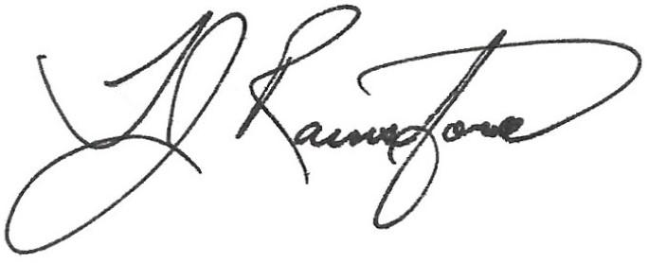

TJ Rainsford

Interim Director

The iConsultancy Experiential Learning Program

| **iConsultancy Statement of Work** | |
| --- | --- |
| **Project Title:** | Landover Hills - Integration of Landover Hills Municipal Data into the Maryland Open Data Portal |
| **Start & End Dates:** | January - May 2025 |
| **Project Needs Assessment:** | The Town of Landover Hills seeks to enhance resident participation in local governance and community activities. To achieve this, the town needs to understand residents' interests, priorities, and preferred methods of engagement. A structured survey will help identify the most pressing community issues, determine what types of committees or initiatives residents are interested in, and explore effective strategies to sustain long-term involvement. |
| **Project Scope:** | The project scope will include the following goals and outcomes:   * An initial project briefing - the client will present an overview of relevant aspects of the organization; their stakeholders; the role of the platform in supporting the organization's mission; and perceived problems, challenges, and opportunities. UMD team and the client will review project goals and objectives, and establish regular meeting times * A Requirements Document confirming project needs, technical requirements, and non-technical requirements * Designing and developing a survey to assess resident interest in community engagement. This survey will involve:   + Identifying key areas of interest for community involvement, including potential committees and initiatives.   + Determining the most pressing issues in the community that could benefit from increased resident participation.   + Gathering input on preferred levels of engagement, time commitments, and communication methods. * Researching best practices for community surveys to maximize response rates and actionable insights. * Developing strategies to encourage long-term participation beyond initial engagement. * Final presentation to the client and other stakeholders * Final report on project outcomes, inclusive of any recommendations |
| **Project Deliverables:** | The project deliverables will include:   * Survey Design Document – A detailed plan outlining survey objectives, key questions, and methodology. * Draft Survey – A resident-friendly survey designed to gather meaningful insights on community engagement preferences. * Survey Distribution Plan – Recommendations on how to effectively distribute the survey (e.g., online platforms, mailers, town events). * Engagement Strategy Report – A summary of best practices for increasing resident participation and sustaining engagement. * Final Presentation – A report and presentation to town officials summarizing survey content, distribution recommendations, and proposed strategies for ongoing community involvement. * Final report and presentation to stakeholders, including recommended next steps |
| **Client-provided Resources:** | The client shall provide:   * Access to relevant organizational materials and staff members as needed * Staff member(s) available to attend the initial project briefing, check-in meetings, and presentations as defined by the project schedule * Feedback to students on work products and deliverables * Feedback to instructors on student work quality, communication, and professionalism so instructors can better guide students |
| **Client Contact Information** | |
| **Organization:** | Town of Landover Hills |
| **Primary Project Point of Contact:** | Jeffrey Schomisch, Mayor |
| **Primary Email:** | j.schomisch@landoverhills.us |
| **Primary Phone:** | 301-773-6401 |
| **Alternative Contact:** | Rommel J Pazmiño |
| **Alternative Email:** | r.pazmino@landoverhills.us |
| **Alternative Phone:** | 301-773-6401 |

**Terms and Conditions**

By agreeing to this scope of work for project services, you agree to the following:

* This agreement is subject to University of Maryland policies for academic course sponsorship, available at <https://ischool.umd.edu/iconsultancy#terms>.
* The organization has assigned a Primary Project Point of Contact, identified above, who is available to interact with the iConsultancy, instructors, and students for a minimum of two (2) hours per week per semester (30 hours total). This includes availability to attend a requirements gathering meeting at the beginning of the semester, project check-ins, a (potential) mid-semester project update, and the end-of-semester final deliverable presentation. The Primary Contact should be able to respond to student email requests, provide feedback to students on work products and deliverables, and provide feedback to instructors on student work quality, communication, and professionalism.
* Scope Changes - After acceptance, both parties must agree on changes to the scope of work. The iConsultancy reserves the right to restrict changes to the scope of work to ensure the quality of the outcome and the educational process.

You may confirm your acceptance and agreement to this scope of work by affirmatively responding via email to [iconsultancy@umd.edu](mailto:iconsultancy@umd.edu) or signing below and returning.

ACCEPTED AND AGREED TO:

__________________________________

Organization Point of Contact

__________________________________

Project Point of Contact

__________________________________

Date